# Mobile Geography Summary

**Overview**

The mobile landscape is growing, both in usage and solutions. Customer statistics and internal interest have charted this exceptional amount of growth in the mobile channel. This has resulted in various lines of business pursuing mobile representation of their products, both internally and externally facing. With the understanding that one size does not always fit all, this project is being undertaken to produce and deliver supporting information around mobile frameworks – information that only comes by doing.

This effort involves undertaking a set of mini proofs of concept using various mobile frameworks in a similar use case in order to demonstrate and quantify the pros, cons and learnings of each. The ultimate goal of this project is to provide documentation that could be used to determine the best mobile application strategy for a given effort given various requirements and attributes.

**Key Findings**

* None of the mobile frameworks tested can create a good experience translating from smartphone to tablet; they do not account for the screen difference and do not look adequate.
* Certain functions may be simpler (cheaper and more effective) to implement using other 3rd party APIs vs. those provided by the frameworks. Integrating maps using the Google Maps API is one such example.
* Common features such as access to GPS are provided by HTML5
* The speed of development is increased using the mobile frameworks
* A comment about the different frameworks not competing in the same space
* Experience is vastly improved for frameworks that leverage popular languages (e.g. JavaScript), making research and learning curves much easier as opposed to frameworks that use a proprietary language

**Project Assumptions**

The scope of this effort is to compare mobile technology architecture and development tool frameworks and ultimately demonstrate pros and/or cons for combinations of architectures & frameworks.

This effort will include devices based on internal and external considerations, with mobile market share defining the device and OS scope.

* Android OS 2.2+
* Apple iOS 4.x+

This effort needs to take the simplest path to create the use cases using the different frameworks. Any requirements that do not contribute to the framework comparison will not be considered for this effort.

Certain capabilities fall into the responsibility area of mobile device management (MDM) or the network/carrier. Mobile frameworks that offer capabilities in these areas will need further assessment to determine the right positioning relative to existing offerings from the enterprise. This assessment will be separate from this PoC effort.

**Context**

Frameworks were chosen based on a combination of capabilities, market share and existing relationship with Wells Fargo. Other variables considered:

* Generally prefer open-source, non-proprietary solutions
* Type of technology and existing knowledge base
* Flexibility for future change
* Security
* Access to device features
* Ability to deal with large data sets

The project moved ahead using PhoneGap, Titanium Appcelerator and Antenna.

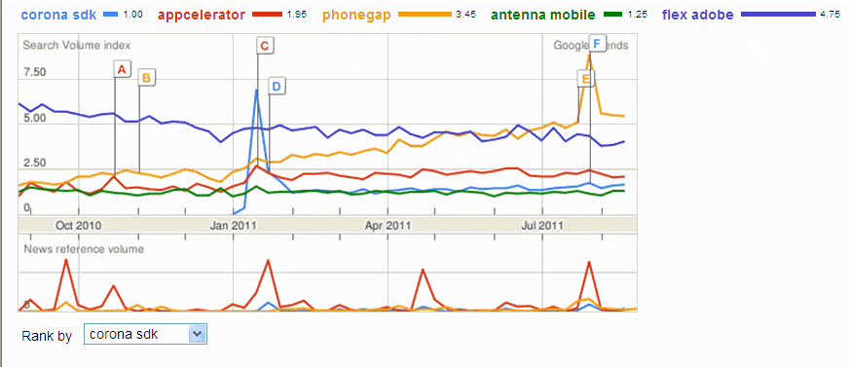

A snapshot of trending players 8/31/2011

These mobile frameworks were each used to create the same use case: an expense management tool that relies heavily on large data sets and utilizes many of the native device features. The attributes chosen for review and their respective outcomes can be found in The Results section.

## Framework Overview

### PhoneGap

PhoneGap is one of the most popular cross-platform development frameworks. It is an open source project with a robust developer community. PhoneGap provides two important things: a) an environment for building what are essentially web apps, and b) a consistent JavaScript API for accessing native device capabilities. PhoneGap gives you full flexibility to start with standard web technologies (HTML5, Cascading Stylesheets (CSS), and JavaScript) and then add popular frameworks such JQuery Mobile or Sencha Touch to build richer (i.e. native-like) user interfaces.

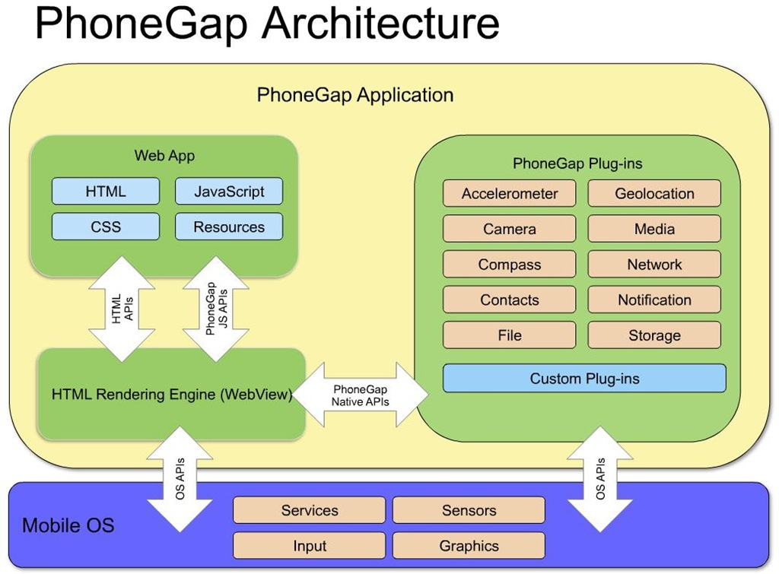

Figure 1 - PhoneGap Architecture courtesy of Bryce Curtis, IBM

### Appcelerator Titanium

Appcelerator Titanium is another open source cross-platform development framework. Titanium provides a pure JavaScript API for developing your app user interface. Through this API, you also get access to numerous native device capabilities. Titanium apps are written entirely in JavaScript and get “translated” on-the-fly to native code at runtime. Appcelerator has built a solid ecosystem around their platform. The base framework is available for free. Enterprise modules (e.g. prebuilt connectors) are available at a cost. There’s also a marketplace to purchase third party extensions to the platform.

### Antenna Mobility Platform (AMP)

Antenna’s solution includes not just a multi-platform development framework, but also a middleware that facilitates backend integration, app management, and other security. Development is done through AMP Studio which allows you to rapidly prototype UIs and connect them to various data sources. The underlying scripting language used is proprietary. For deployment, apps are compiled into native binaries. Antenna apps are tightly coupled to the AMP middleware components; they are akin to Blackberry devices being dependent on BES.

### Comparison

|  |  |  |  |
| --- | --- | --- | --- |
|  | PhoneGap | Appcelerator Titanium | Antenna |
| Access to Native Device Capabilities | Yes* | Yes* | Yes* |
| Multi-platform Development | Yes | Yes | Yes |
| Development Language(s) | HTML5, CSS, JavaScript | JavaScript | ?? (Proprietary) |
| App Packaging and Execution | Hybrid app | Native app /  Interpreted JS | Compiled native app |
| IDE | Developer’s choice  (e.g. Eclipse, Visual Studio, Dreamweaver, etc.) | Titanium Studio | AMP Studio |
| Documentation | APIs, wiki, and other resources all publicly available.  [Books also available @ Amazon](http://www.amazon.com/s/ref=nb_sb_noss_1?url=search-alias%3Dstripbooks&field-keywords=phonegap&x=0&y=0&ajr=2) | APIs, wiki, and other resources all publicly available.  [Books also available @ Amazon](http://www.amazon.com/s/ref=nb_sb_noss_1?url=search-alias%3Dstripbooks&field-keywords=appcelerator&x=0&y=0) | Available only to customers and partners |
| Support | Public community forums, professional subscription-based support also available | Public community forums, professional support also available | Part of licensing |
| Software License | Open Source / [Apache](http://en.wikipedia.org/wiki/Apache_License) | Open Source / [Apache](http://en.wikipedia.org/wiki/Apache_License) | Closed Source / [Proprietary software](http://en.wikipedia.org/wiki/Proprietary_software) |
| Software Cost | Free as in beer | Free for base framework | Varies |

* Refer to findings below for details

# 

# The results

|  |  |  |  |
| --- | --- | --- | --- |
| Attribute | PhoneGap[1] | Titanium | Antenna |
| Geolocation |  |  | Implemented  Implemented with difficulties  Not successful  NA Not attempted  NS Not supported |
| Phone |  |  |  |
| Contacts |  | [2] |  |
| Video Playback |  |  |  |
| Camera |  |  | [3] |
| Calendar | NA | [4] | [5] |
| Notifications[6] | NA | NA | NA |
| Speech to text | NS | NS | NS |
| Dynamic content |  | NA |  |
| GUI Features | [7] |  |  |
| Multitouch | NS |  | NS |
| Phone/tablet comparison |  |  |  |
| Animations |  | [8] | NA |
| Performance |  |  |  |
| Local storage |  |  |  |
| Transition iOS/Android | NA |  |  |

**Other Findings**

* In using JQuery mobile there were areas that the UI platform needs maturity
* In many instances the frameworks claimed to have features that the developers were unable to get working
  + Placeholder for examples
  + Charting example due to purchasing issues
  + Titanium utilizes add-on modules that are not necessarily built in Titanium
* Titanium originally supported iOS only, and generally geared toward iOS. Android support added later and more difficult to get working. RIM support in indefinite beta.

1. Time constraints limited PhoneGap experience to iOS
2. Not supported for Android
3. Issue with returning to app
4. Unable to use native calendar, could use date picker
5. Used native API
6. No backend server available for this effort, so limited testing of attributes requiring this
7. HTML5 elements only; no native UI components
8. Unable to implement on Android